User Acceptance Testing:

Below showing is the testing the basic functionality:

1. Assume a car is detected at outside entry pillar sensor. Then LCD display changes to “Push Button” state. And need to press “Issue Adhoc Ticket” button

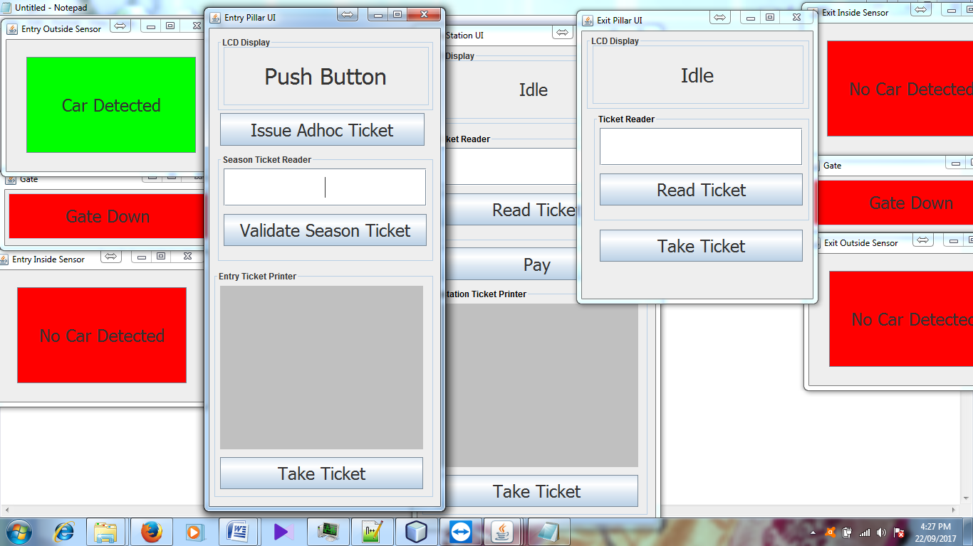

1. After pressing “Issue Adhoc ticket” button, user can get a ticket and should take ticket

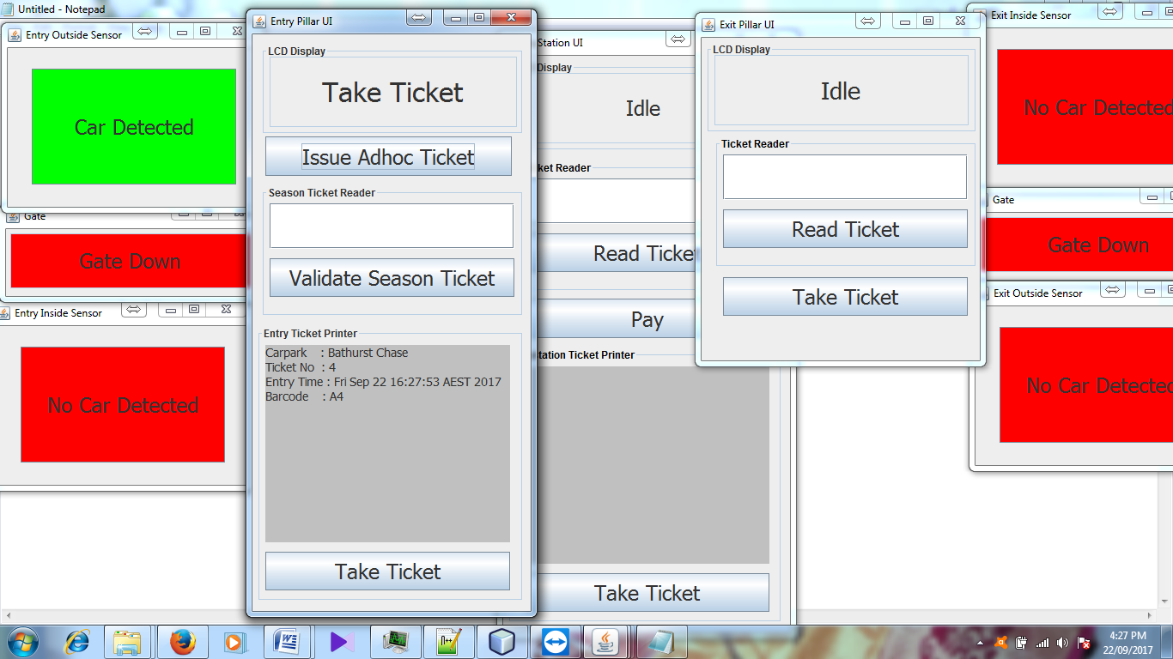

1. Automatically Gate goes up when Ticket is taken, then display shows “Ticket Taken”.

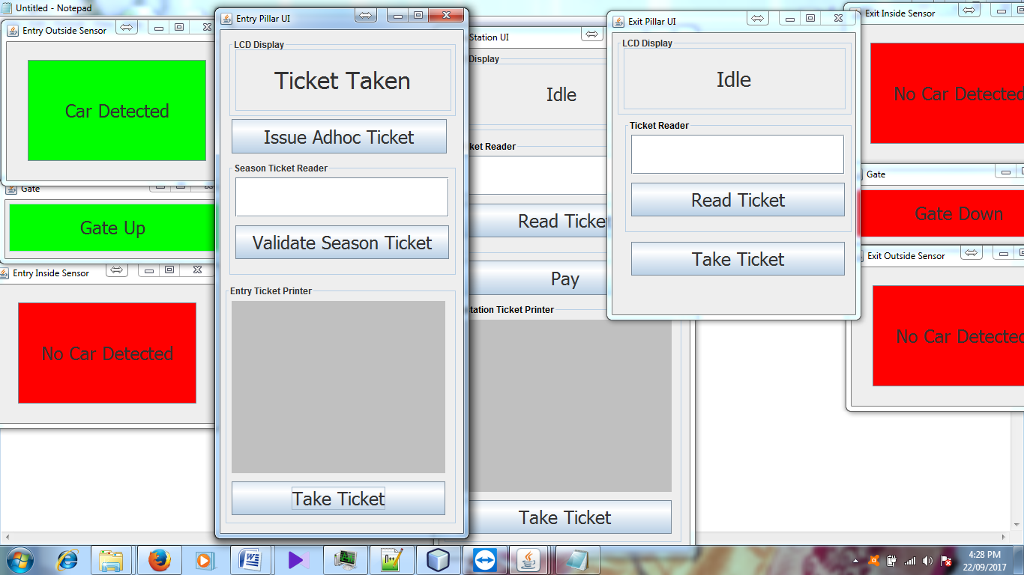

1. When car detects at Inside Sensor Display at pillar shows as “Entering”.

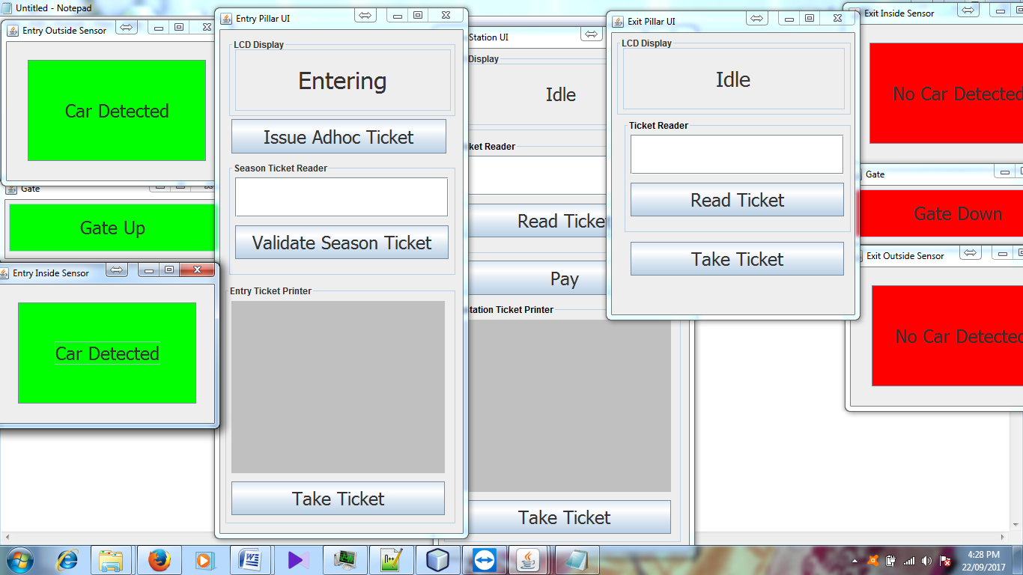

5)When car goes far and enter into parking area then Display shows Entered

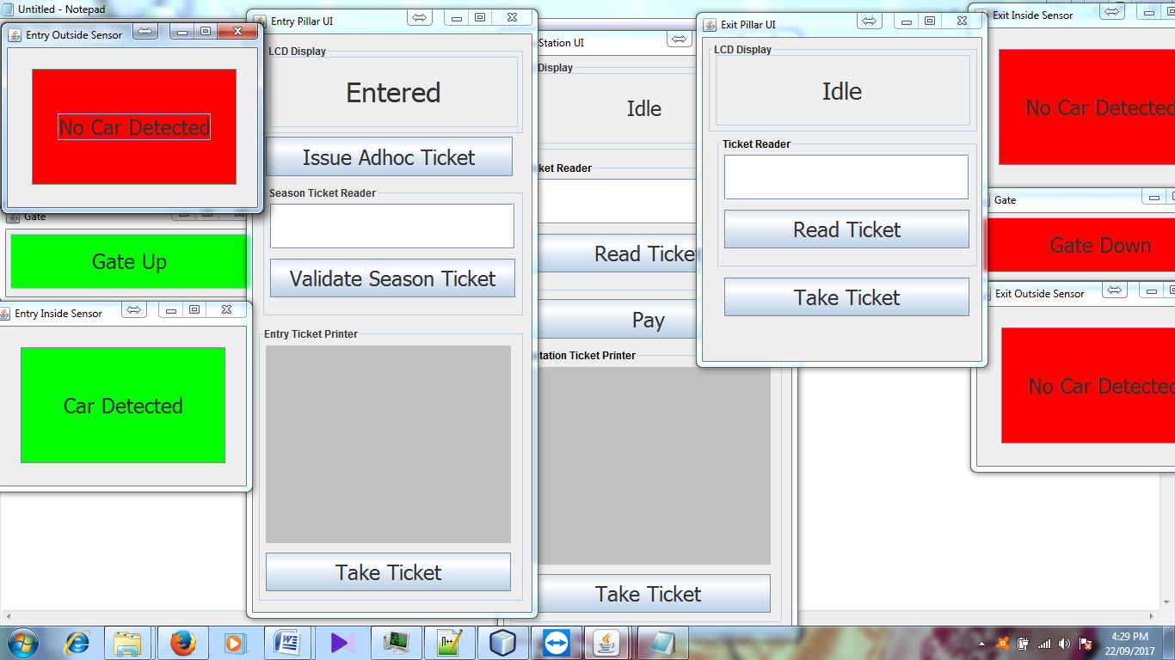

6)When knows car entered to parking then automatically gate downs and Display goes to Idle state.

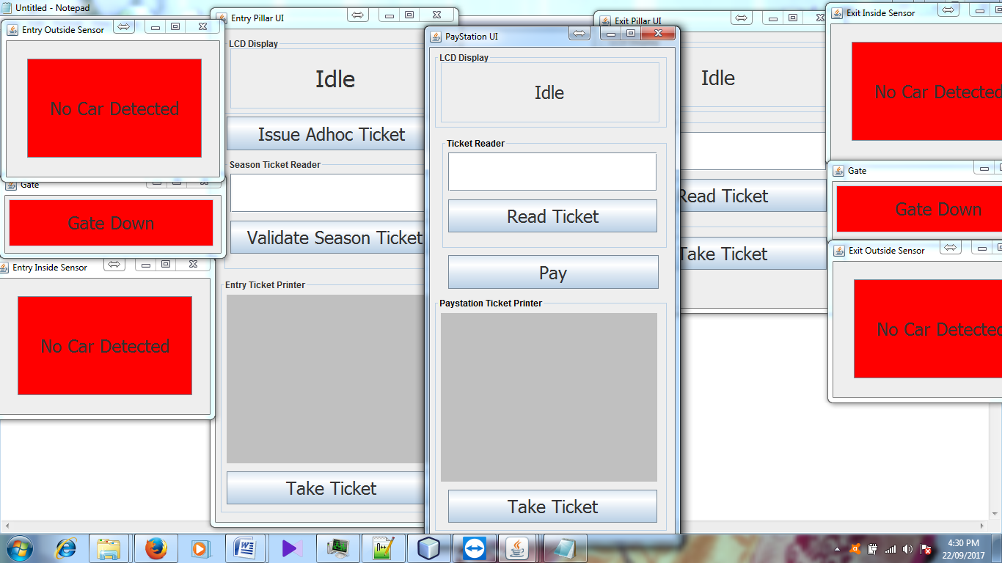

7) When Car want to go out of parking area user needs to pay first, So user needs to insert ticket to the pay station then pay station reads barcode and displays amount.

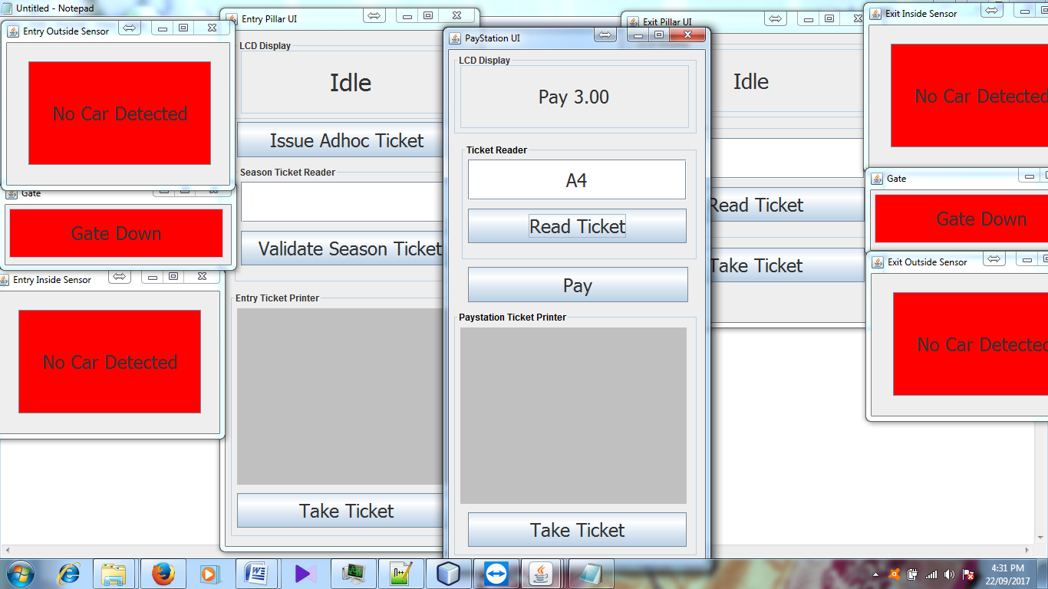

8)Once user pays displayed price then user needs to take processed ticket

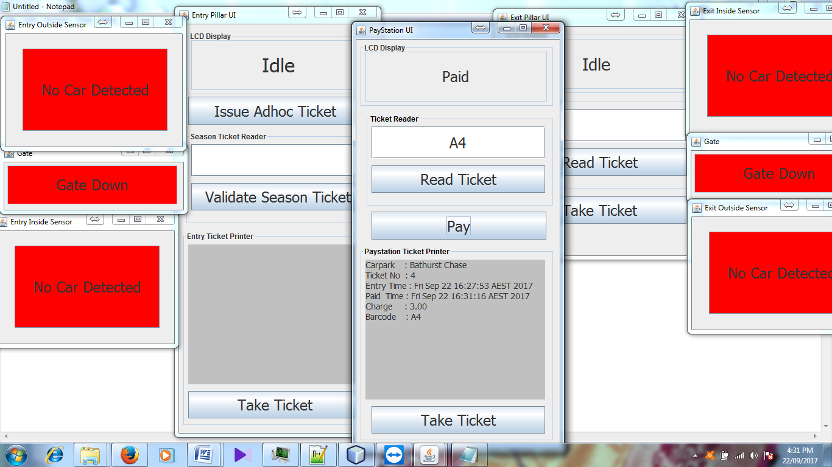

9) Once processed ticket is taken displays restores to Idle state.

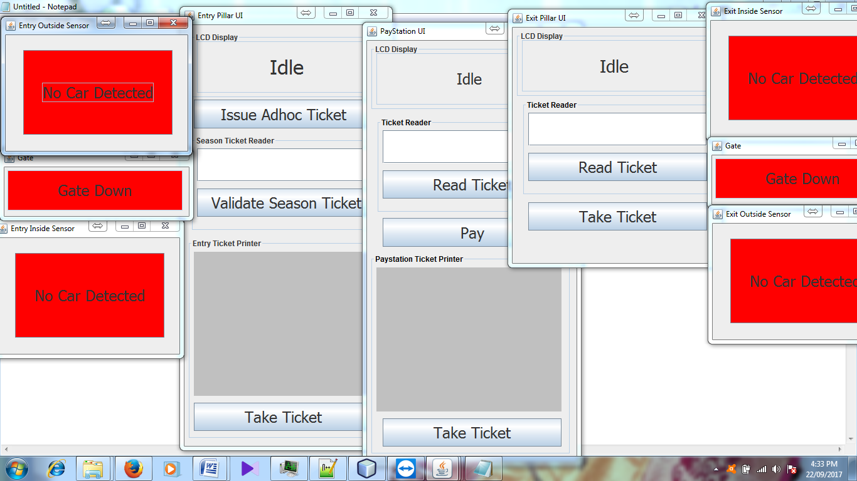

10) Once car detected at outside sensor then Display at Exit pillar shows to “Insert Ticket”.

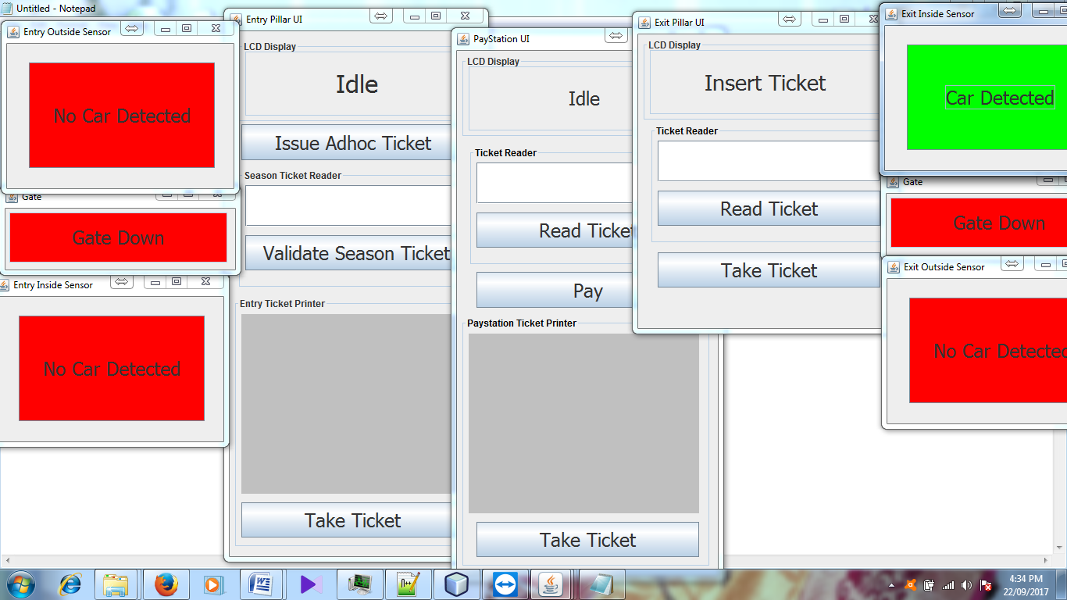

11) user needs to put ticket into Exit pillar and it reads the barcode and check for validation and displays “Take Processed Ticket”.

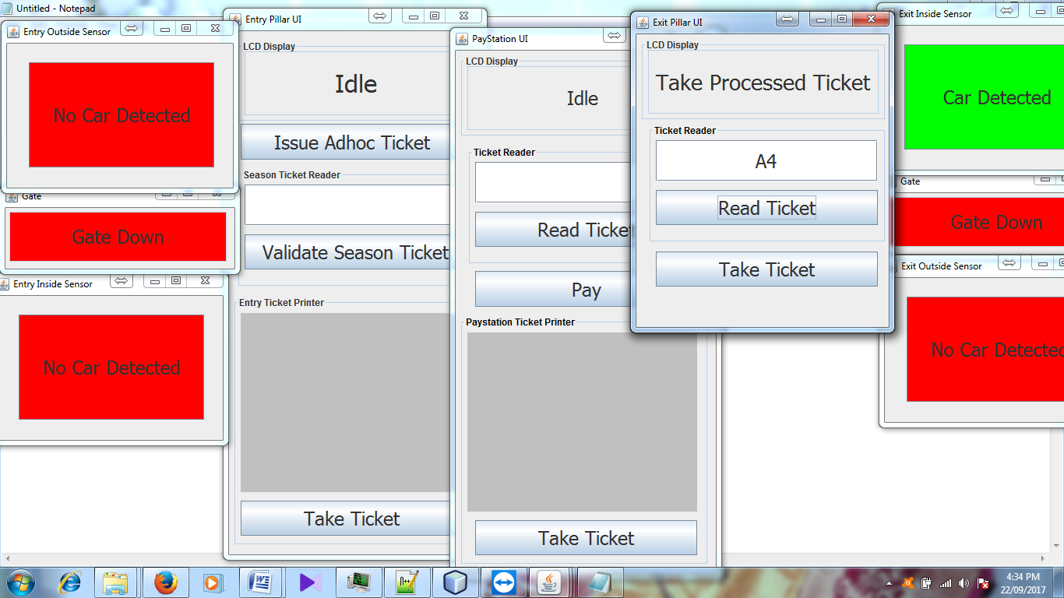

12)Once user takes ticket then display shows “Ticket Taken” and Exit gate goes up.

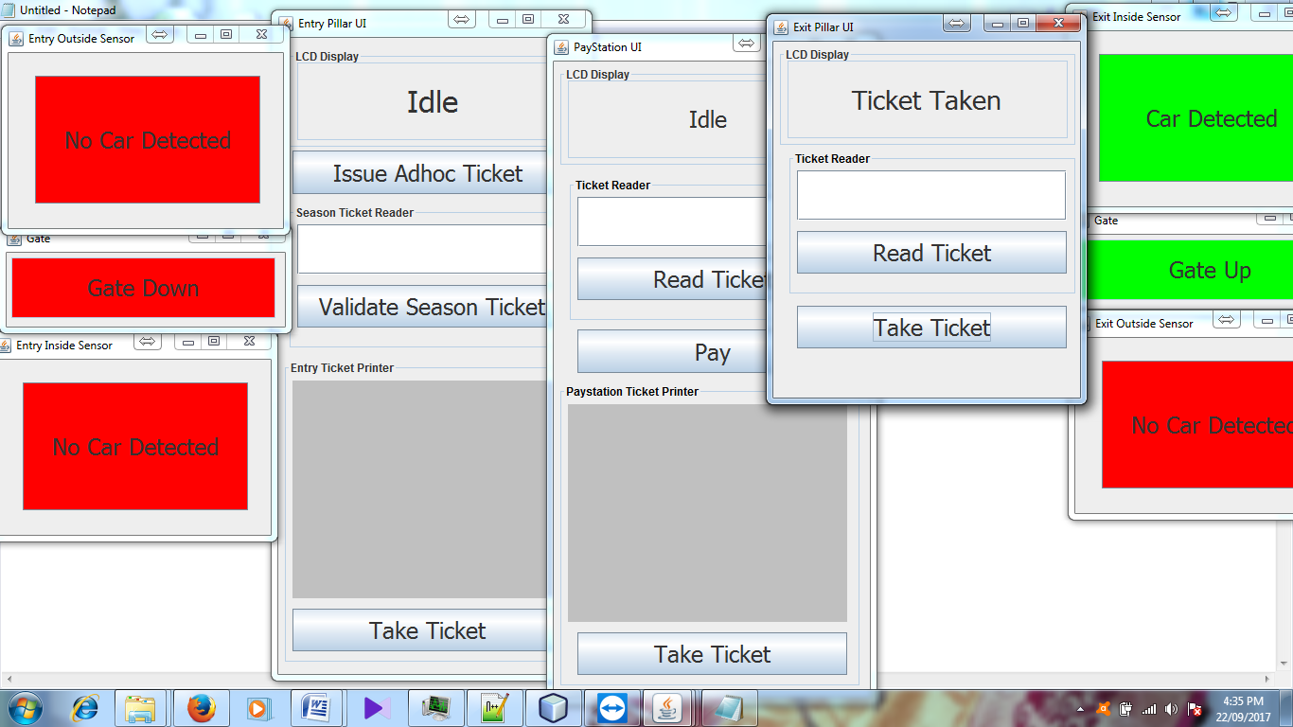

13)Display changes to Exiting when car is detected at Outside Sensor.

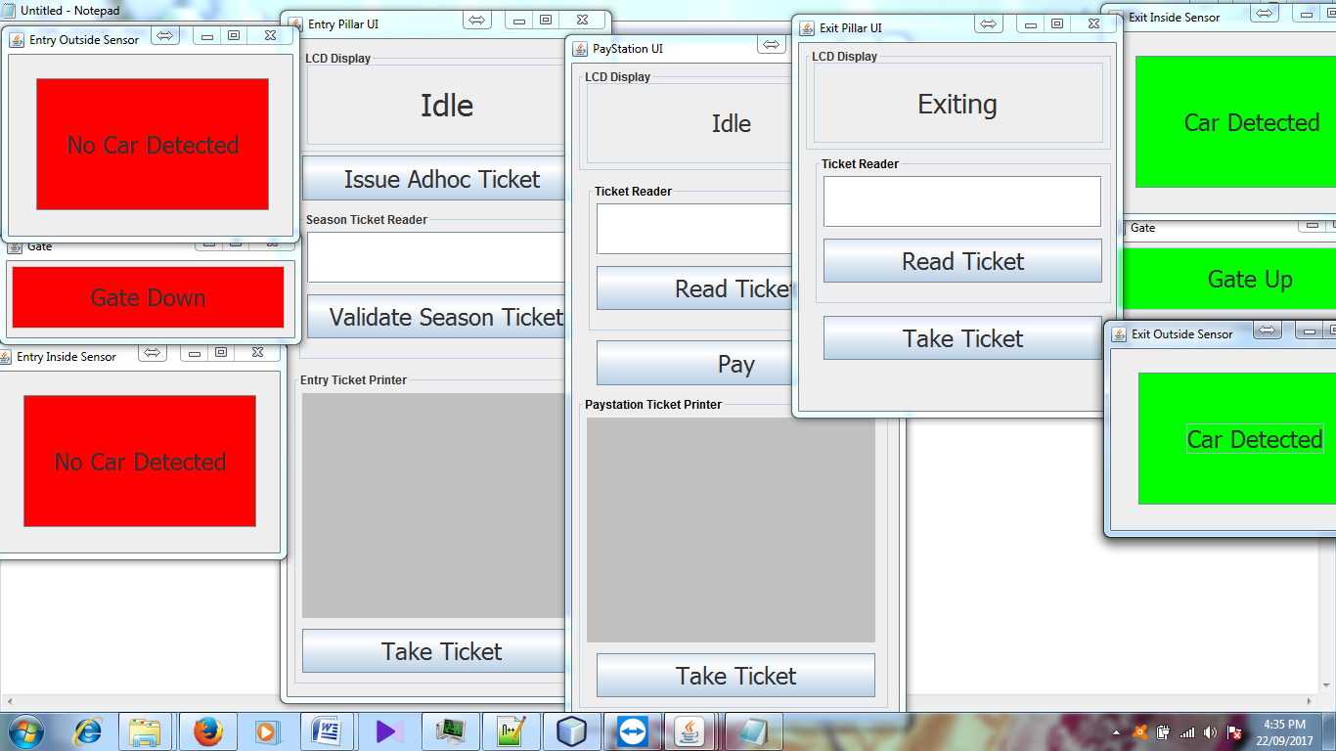

14) When car goes far from Inside sensor Display shows Exited.

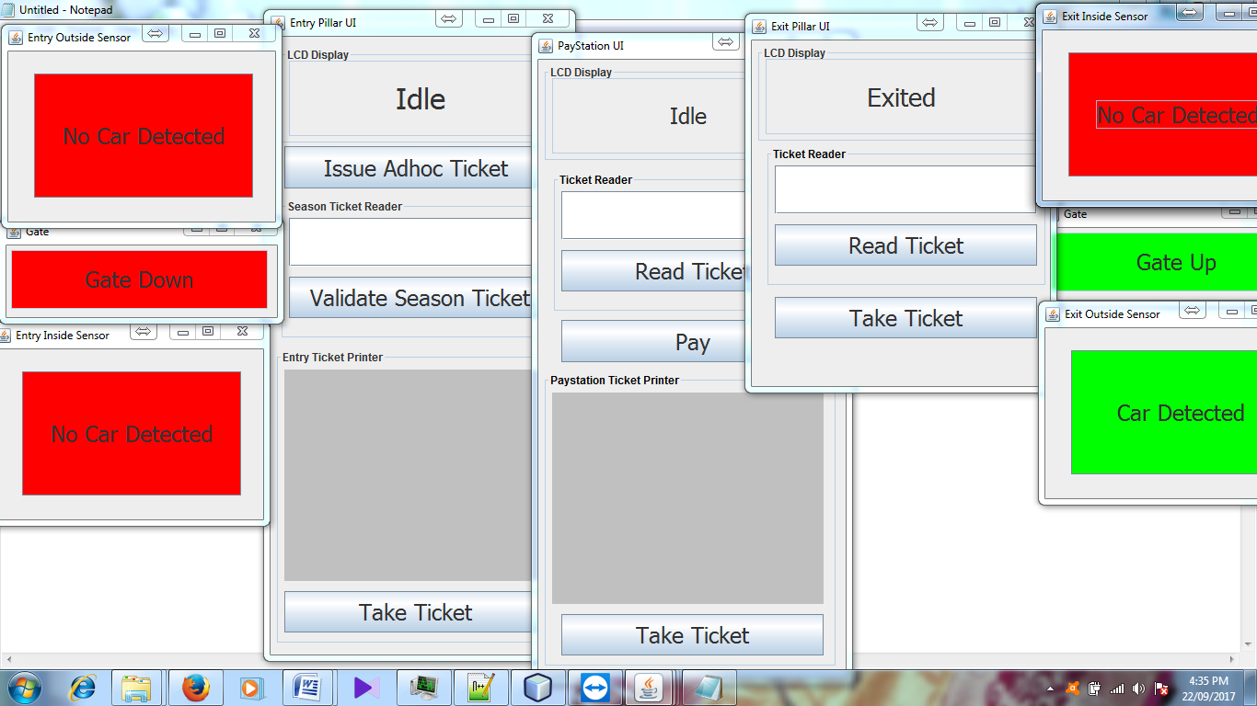

15) Once car out of parking again goes back to Idle state.

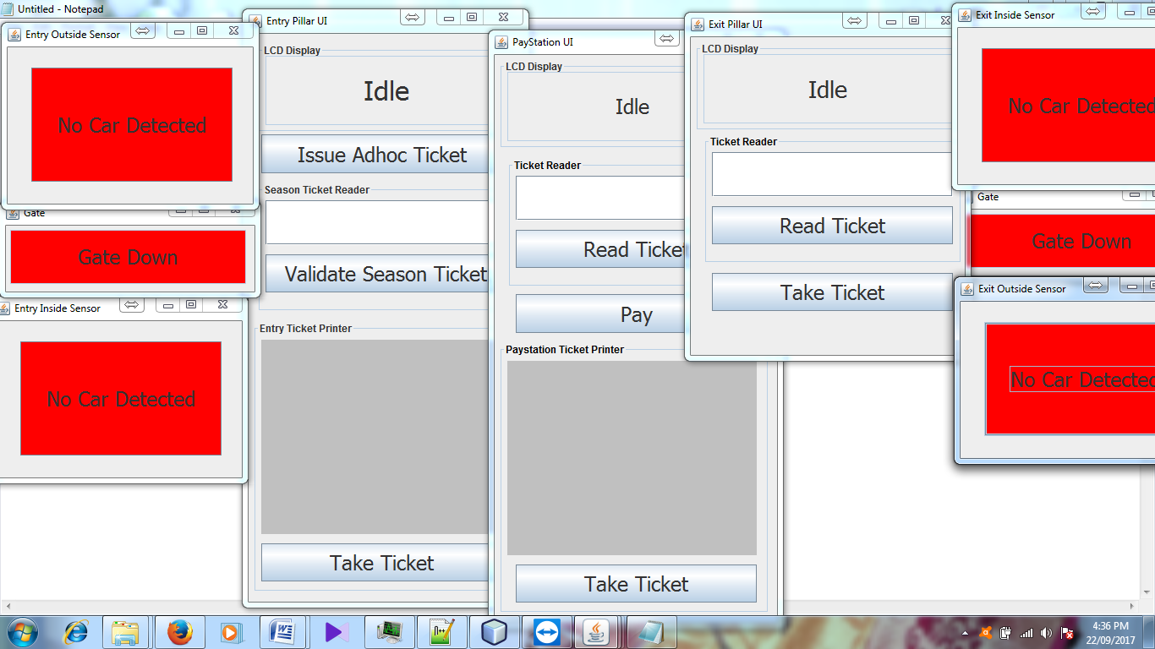

Some other conditions or User errors:

16) If User inserts wrong ticket at pay station display shows “Take Rejected Ticket”. Once user takes ticket then it goes back to idle state.

